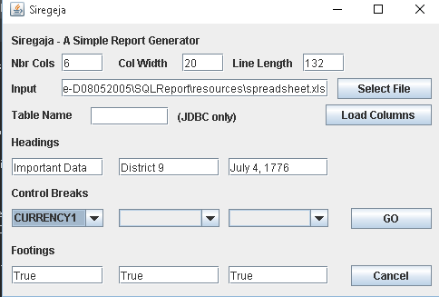
Basic Instructions for using the GUI

- Nbr Cols – the number of input columns which will all be on the report.
- Col Width – a uniform column width for all columns on this report.
- Line Length – the total width of a report line in characters.

The number of columns times the column width is the amount of space reserved for data, and it must be less than the line length. The remaining amount of space is divided up as white space between columns.

- Input – This is the input file or jdbc connection. The input must be a spreadsheet, a csv file, a json file, or an xml file containing tabular (table) data. A jdbc connection can be provided to read a database table.
- Select File will provide a file open dialog and update the Input text box with the path and file name. It's faster and less error prone than typing in the path and file manually.
- Table Name is only used for a database table. The table will be read from the database using the connection provided as Input.
- Load Columns will read the input into memory, retrieve the column names, and load the drop downs used to specify control breaks.
- Headings are report headings. The three lines provided will appear at the top of the report.
- Control Breaks identify fields used to track subtotals. When one of these fields change, a subtotal is displayed. The Input should be sorted in the same sequence.
- Go will perform some validation and then run the report. If Load Columns already loaded the data into memory, the report will run from memory. Otherwise, the file or table is read, and then the report is run.
- Footings indicate whether totals lines are provided. When all three are desired, the report will include subtotals and grand totals at the end.

Usage Notes:

The headings are centered on the line length. If you shorten the line, the headings will move left, and if you lengthen the line, the headings will move right.

Column length starts with a generic value or a guess. I've always spent more time adjusting column width because it's only strictly enforced on a database table. It's tough to anticipate the maximum column width on other file types unless you know your data.

If you need to make ETL type selection for the report, it is suggested that you make these changes and selections and save the data in an extract file for the report. For example, update a spreadsheet to only contain rows and columns selected, and save the result as an extract file. Or execute SQL to manipulate a database table, and save the result in a file for reporting.

An example report is below.

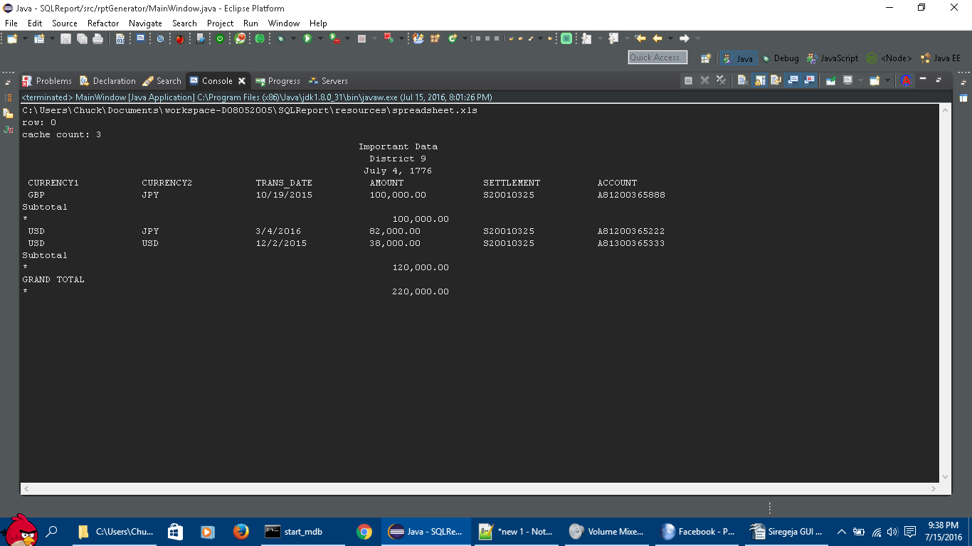
The input was from a spreadsheet with three data types (spreadsheets call this data format). Text columns are displayed as text and the dates are displayed in date format. One column, AMOUNT, is defined as a number, and so it is picked up in the totals. Only numeric data is eligible for totals. The control break field was CURRENCY1, and the subtotal for GBP was 100,000. The second group was USD, and the subtotal was 120,000. The grand total is 120,000.

At the top, the filename is displayed. “row” is a count of rows processed, but it only updates after a thousand rows in processed. “Cache count” is the number of rows returned in the memory cache. As we can see above, only three detail rows were reported.

